Dear Parents and Carers,
Welcome back! We hope you had a lovely Easter break.
This half term in Reception we will be learning all about living things. So this means we will be doing lots of planting and growing (hopefully!)

We are hoping to make some grass head characters as well as planting some strawberry plants from which we can sample the lovely juicy fruit later on in the Summer. We are also hoping to give a home to some minibeasts by designing a bug hotel and of course, plant some tall sunflowers!

To do this we need your help.
- Would you have any old/unwanted clean neutral coloured tights from which we can make our grass heads?
- Could you donate any strawberry plants to us? And some larger style pots?
- Would you have any medium sized wooden boxes. We are hoping to fill these with little sticks to make minibeast hotels.
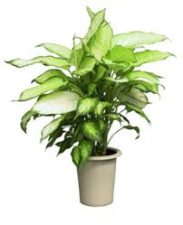
- Finally, if you could donate any soil or sunflower seeds we would be extremely grateful. We are hoping to spend a lot of time outdoors in our Reception playground so if could help us in any of the above ways that would be just amazing!

Thank you for all your help.
The Reception Team

