Our Maya Morning in Year 6
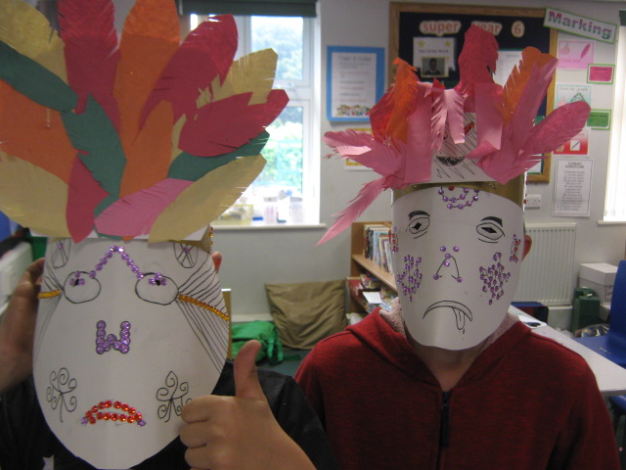
We made masks to help us understand the Maya and we had a visit from Professor Tuesday to help us research them further

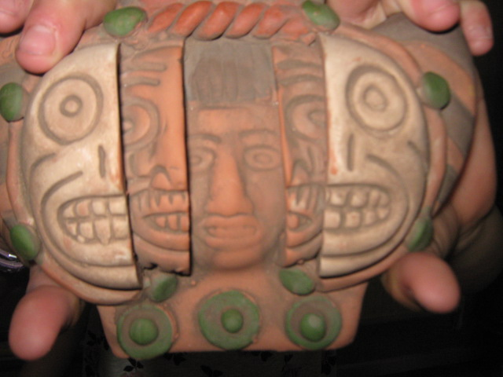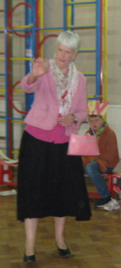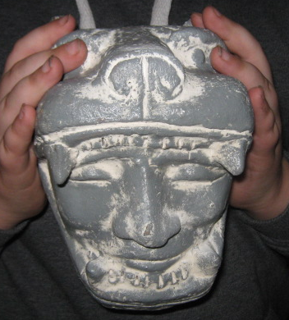

This included learning about their maths, their calendar, their sport, their food, their design and craft and their pyramid building.

