Year 6 Learning about democracy
We started with images, showing one at a time to see if we could work out what they were part?
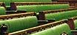
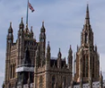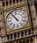

Then we added to a piece of paper what we already knew about our Parliament.
Some said they didn’t think they knew anything but most had a few ideas. Then we watched a short video to see what we could add to our diagrams.

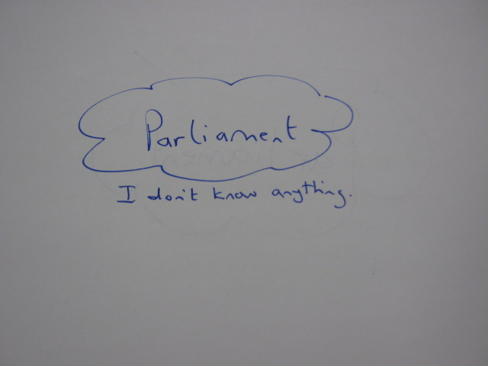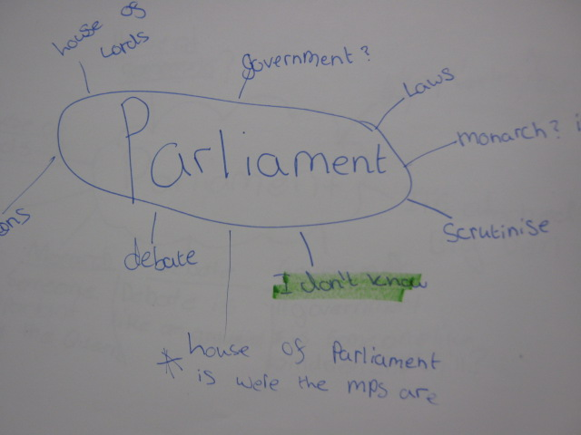

The pink stars show the new knowledge we gained from the video and discussion. Everyone knew more!
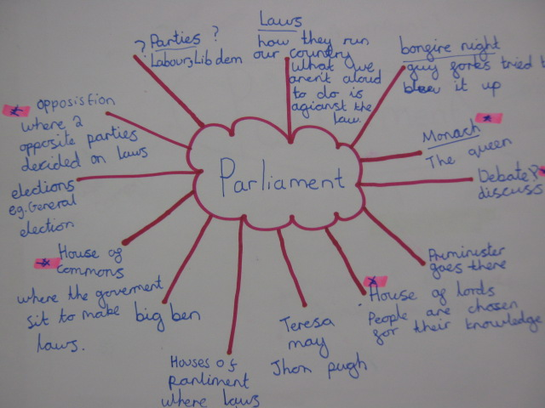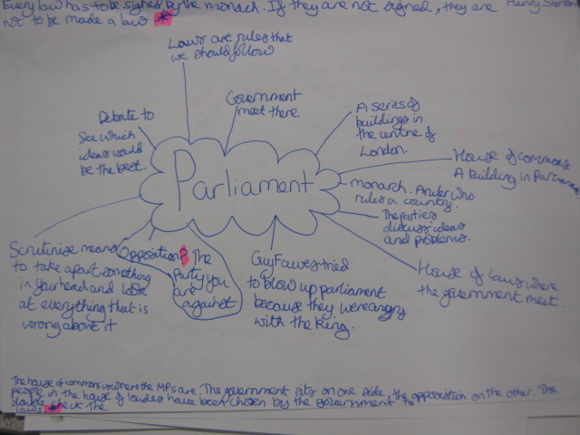
We learned about words like
debate....monarch...scrutinise
We discussed the difference between our Parliament and Government.
We discussed how some aspects of our democracy are controversial.
Should we have a House of Lords? Do we need a monarch?



