Year 6 election June 2017
First they got a ballot paper and put a cross next to the political party that they wanted to win
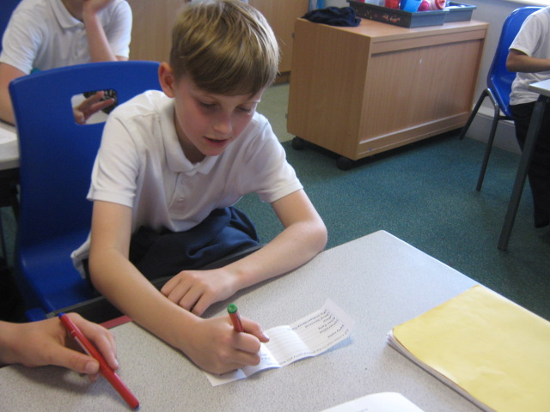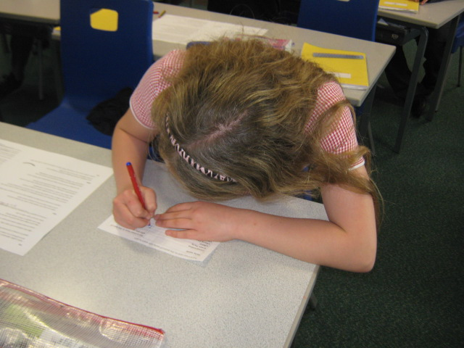
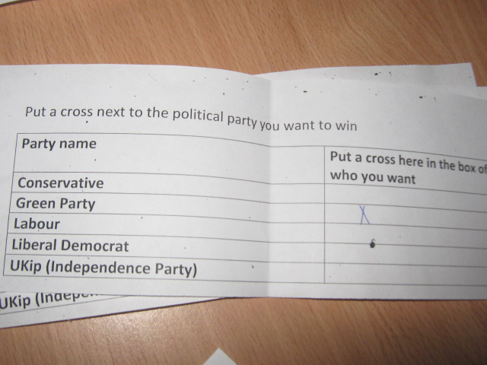
Then we collected them in and made piles for each party

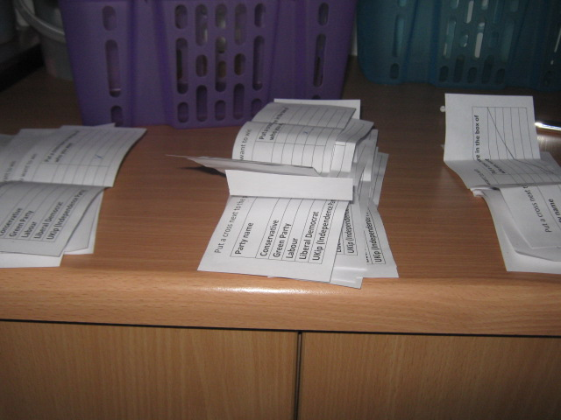
Then we made tally charts to get our results

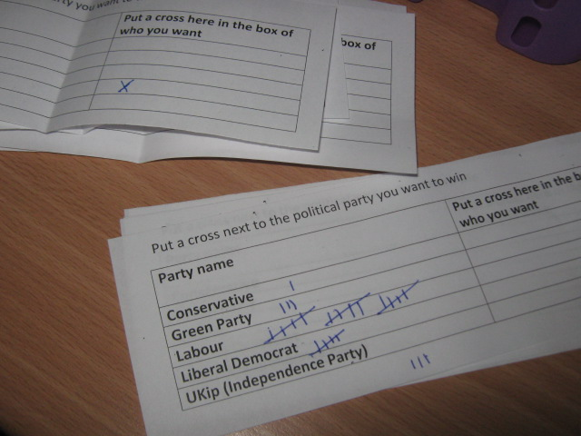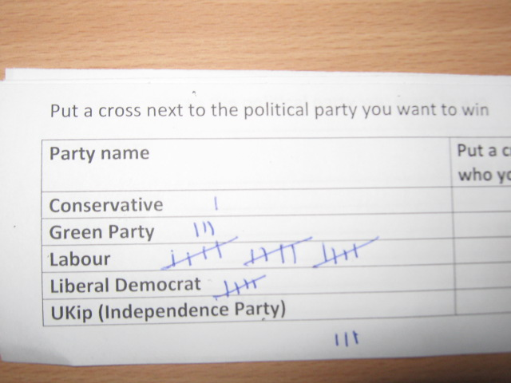
Here were the results
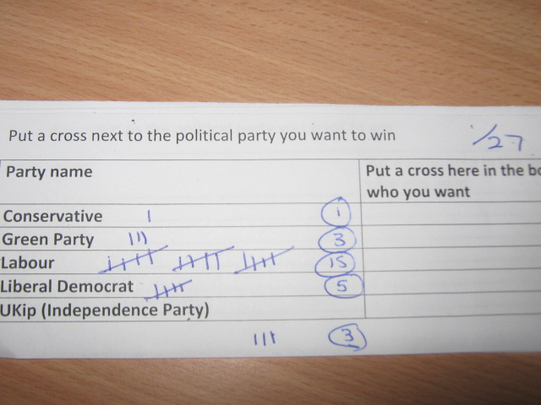

We looked at how they compared to the national vote
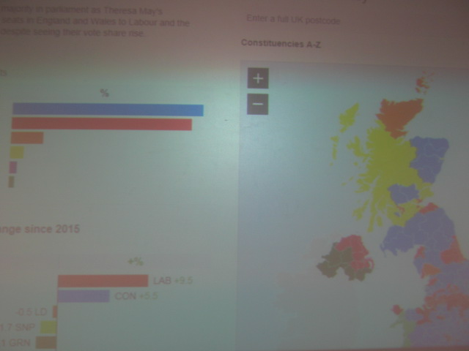
Year 6 results
Party name | Percentage of vote
Conservative | 3
Green Party | 11
Labour | 55
Liberal Democrat | 20
UKip (Independence Party) | 0
Spoiled ballot paper (didn’t want any party) | 11

Labour was easily first for us and the Conservative were second to last
The Greens and Liberal Democrats did better with us
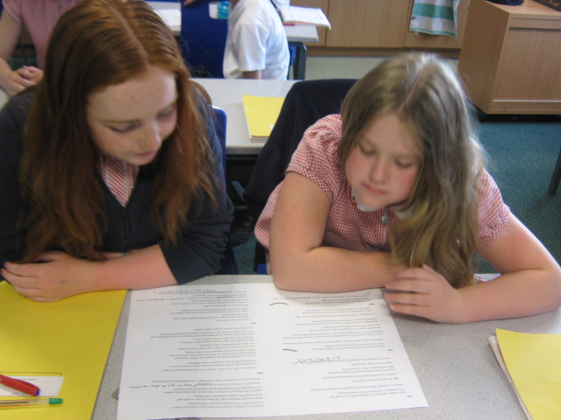
Then we tested out our party allegiances
Pupils looked at simplified manifestos for the 5 main parties - only no party names were on them; they were numbered rather than named
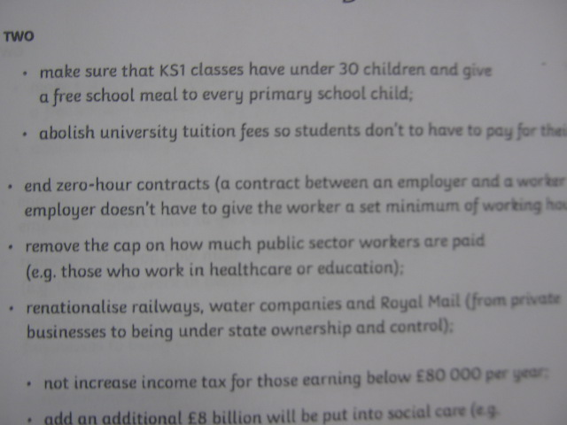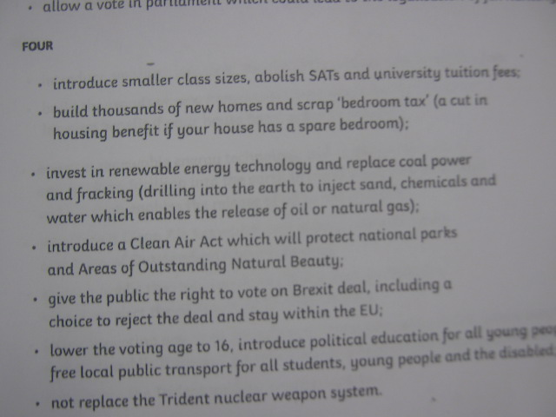
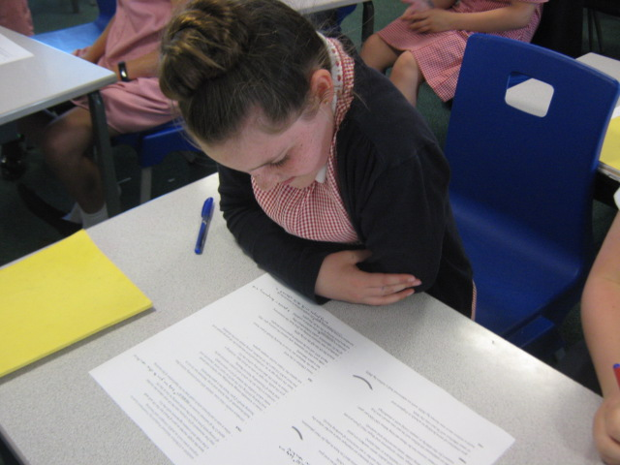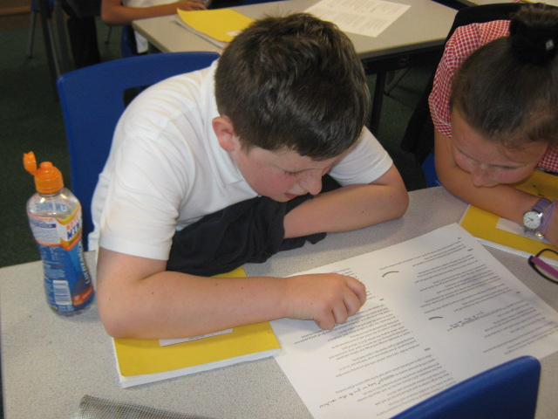
Results after reading the un-named manifesto
Party name | Percentage of vote
Conservative | 3
Green Party | 18
Labour | 44
Liberal Democrat | 15
UKip (Independence Party) | 0
Couldn’t decide | 20
Results from their first vote
Party name | Percentage of vote
Conservative | 3
Green Party | 11
Labour | 55
Liberal Democrat | 20
UKip (Independence Party) | 0
Spoiled ballot paper (didn’t want any party) | 11
This suggests the pupils had a good idea of what they were voting for the first time round
Questions we were able to answer together:
“Don’t you have to get more than 50% of the vote to win?”
“How did the Conservatives get so many more MPs than Labour?”
“What is a manifesto?”
“Why would you spoil a ballot paper?”

