Key Vocabulary
Science - Everyday Materials
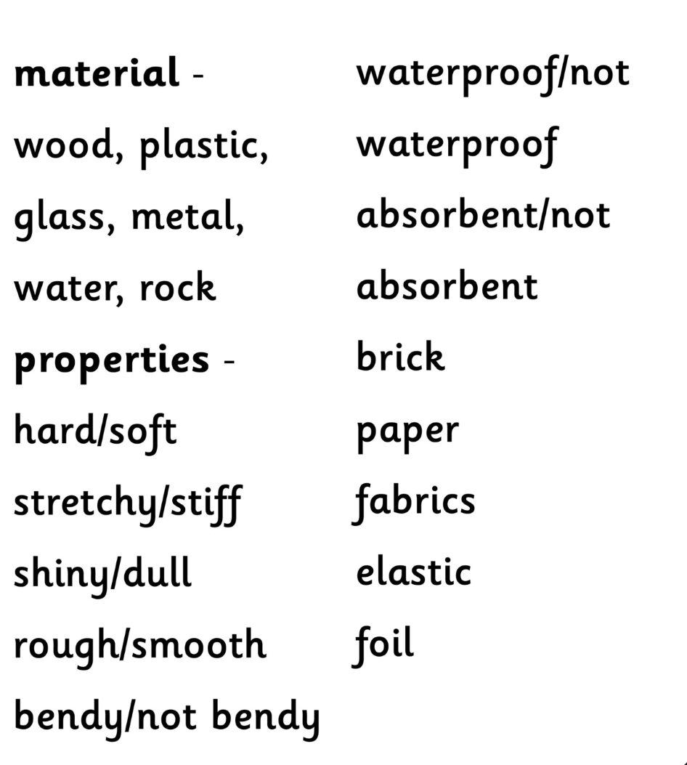

Geography - Map Skills
Compass
North/South/
East/West
Map
Globe
Trail
Plan
Birds Eye View
Symbol

RE – Harvest
Harvest
Types of food
Food names
Prayer
Christian Aid

