
Keep practising the real and alien words for the Phonics screening check. This will be in week 2,
11th – 15th June.

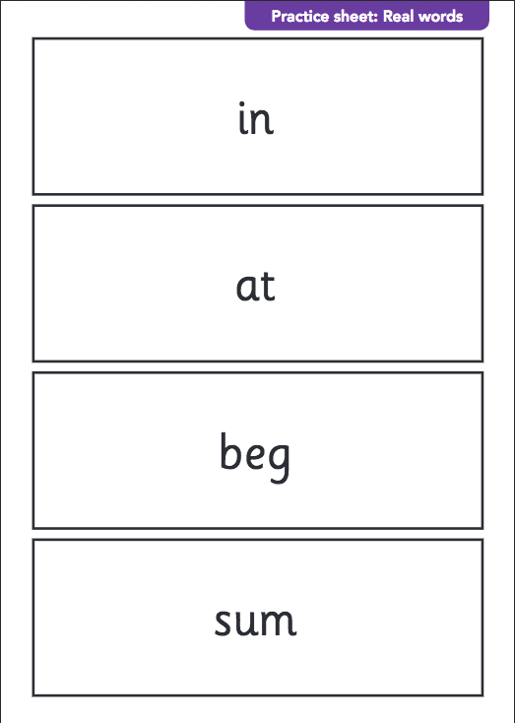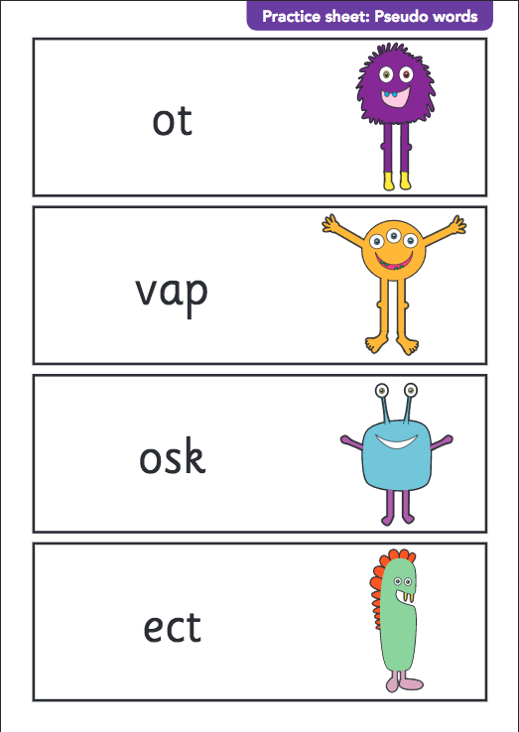
Take a look at the website below for free games and articles linked to the phonics check.


