Year 6 How does Parliament work?
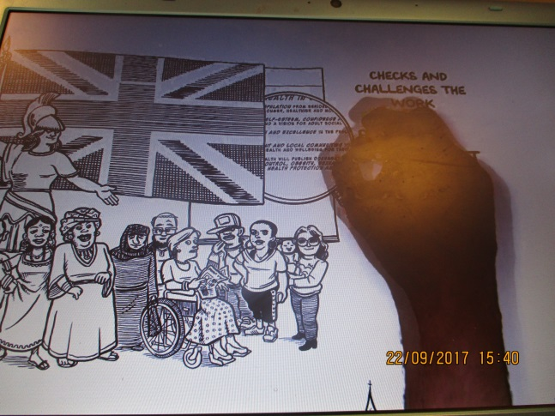
We used this 60 second video from the Parliament.UK website to increase our knowledge of how Parliament works.
We started by writing in pencil to show what we already knew and then we wrote in pen whilst watching the video. We worked in groups to try and get the most answers. By the end we knew a lot more.


