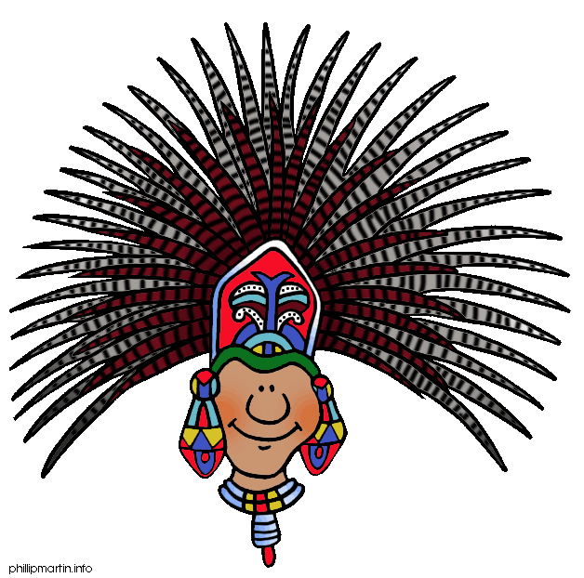
Half term challenge.
Get creative and make your Mayan mask and/or headdress ready for our Maya Day
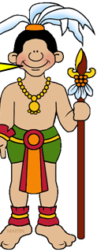
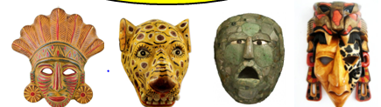
You have until Tuesday June 19th to make and bring in either a Mayan headdress, a mask or both!

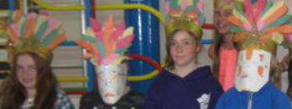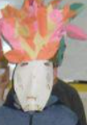
Here are some examples from last year
The Maya loved feathers. Your headdress could be made from feathers
cut from coloured paper.
Recycling paper from magazines could look good for this.
A mask could be made to look like an animal or just a patterned mosaic.
We’d like you to look as Mayan as possible on the day…so please come in non uniform that is plain but ideally add to it a bright shawl or blanket.

If it is not possible to do this at home, there will be two lunch time sessions on June 11th and June 13th for pupils to do this.
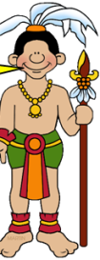
All pupils must complete this task.

