
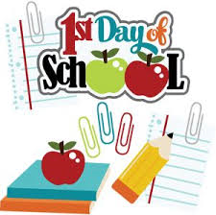
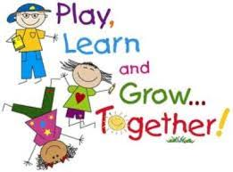

Dear Parents and Carers,
Welcome to the St Philip’s family!
Your children have gotten off to a great start on their new adventure in Reception and we look forward to getting to know them over the next few weeks.
Just a few points to note:
- If any of you have not returned the blue information sheet about who is allowed to collect your child from school and medical information, please return it as soon as possible. Should you need a spare, please come and see us.
- Please ensure you have filled in the 2 menus for school dinner choices.
- Children start full time on Monday 18th September.
- PE will be on a Tuesday and Thursday. Please ensure your child brings a PE kit (fully labelled) in a draw string bag.
- Please bring in a water bottle clearly labelled with your child’s name.
- Homework books will be sent home after the first full week at school. The homework will be an opportunity for you to be creative with your child. Have fun!
- Your child will have an opportunity to take home a library book from next week. Please use this to share with your child. We cannot overemphasise the importance of reading and sharing books together. Enjoy it!
If you have any questions, please do not hesitate to arrange an appointment with myself or Mrs Rimmer.
Many thanks, Mrs. Maguire.
Upcoming dates:
10th September 10.30 – Back to school Sunday in Church
18th September – Children start full time.
9th October 2.15 – Harvest Assembly (Parents welcome – Church)
11th October 2.30 – Buddy Assembly (Parents Welcome – School Hall)
Wow Certificates:
If your child does something amazing, why not fill out a WOW certificate so we can share it in school. Please ask for more or get them from the website.
Our topics this half term:
This half term we will be learning all about ourselves. We will be talking about things we like and are good at. We will notice differences between us and celebrate them.
We will also be exploring Autumn and Harvest themes.

