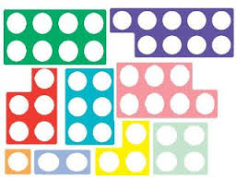Reception Homework – 1
Please return before 4/10/17
This week, as well as settling into school, we have been learning number rhymes to help us remember how to form and recognise our numbers.

Your challenge for homework is to work with an adult or older sibling to create a 3d model of your favoutite number. It can be as wacky as you like. We love recycling in Reception so junk models are always welcome. Please also have fun learning the number rhymes. See if you can use your magic finger!
Thank you to those of you who have brought in your “All about Me!” bags. Please make sure to include a family photograph for our display. 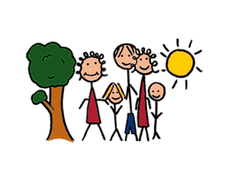

Over the next two weeks we will be learning all about owls. We will read the story “Wow , said the owl” and discuss our colour preferences. This will lead us nicely into “Handa’s Surprise” where we will explore Handa’s adventures in Africa.
Parents comments:


