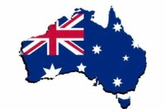History/Geography Competition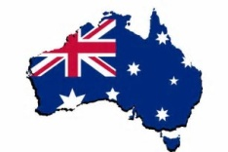
The Commonwealth Games are in AUSTRALIA in 2018
Your challenge is to research and present on one of the following topics:
History of the Commonwealth Games OR Australia
Geography. What is there to see if you go on holiday to Australia? Tell us about the animals, the natural features or the cities.
How could you do this?
As a speech bubble…As a poster...As a fact file…As aboriginal art
The panel of judges will give marks for:
Detail
Interest
Effort
Hand in to the Year 6 classroom by January 16th
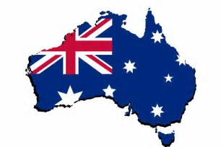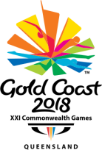

More ideas…
History…who are the Aborigines and what is their culture like?
How and when did Europeans first find out that Australia even existed?

The Commonwealth Games used to be called the Empire Games…what can you tell us about this?

What countries compete in the games?
What sports are part of the games?

Geography…there is a lot of variety in Australia…
You could tell us about rainforest or desert or the Great Barrier Reef
What is Uluru?
Tell us about kangaroos, koala bears, emus…


