February Half Term…Commonwealth Games Competitions
Choose from…
Collecting a sheet with events logos from Y6 and finding out what sport they are for

OR
Find out and make a poster to show what events were included in the first Commonwealth Games in 1930 and what events are held now…who was allowed to compete and which countries took part compared to now
OR
Design a flag for the Commonwealth
Below is the current flag…find out about it and see if you can design a better one that helps convey some of what the Commonwealth stands for such as…
It is 1/3 of the world’s population across the globe and 60% of that total are young people (under 30 years of age)…it aims to promote equality, democracy, tolerance, freedom, peace, saving the environment, improving access to health care, education, food and shelter
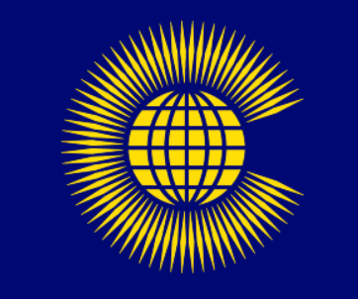
Any questions see Ms Lund in Y6…Closing date is February 22nd (Thursday)

