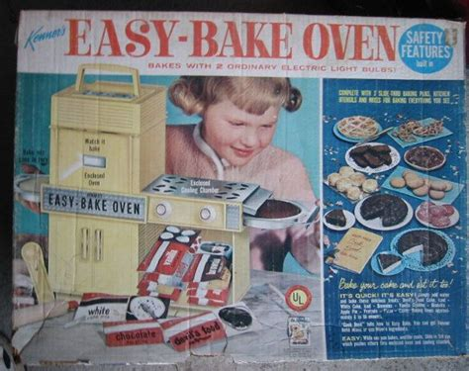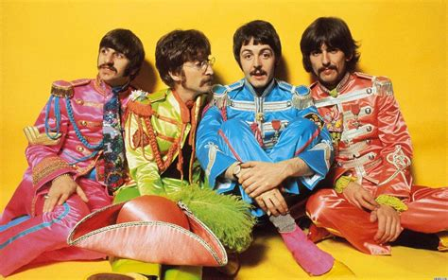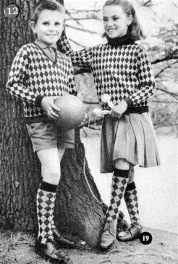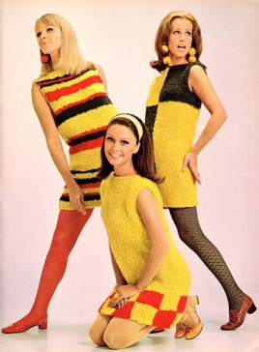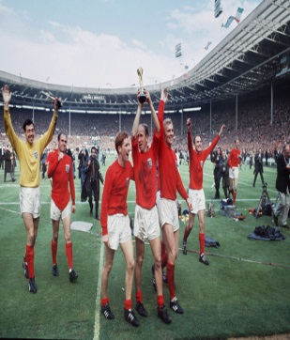
Easter history competition
Has childhood changed much in the last fifty years or so?

Talk to your relatives and find out what was similar and different about their childhoods in the 1960s and 1970s…compared to yours now. This would include toys, food, clothes, routines, treats, music, school, sport, holidays….
Present your findings in one of these ways
a poster…a video…a lego movie…a poem…an essay
You will be judged on the following aspects:
Detail (that you point out lots of similarities and differences and that you weigh these up to give a conclusion)
Interest (that you present what you find in an eye catching and interesting way)
Effort (that we can tell you took time and pride in how you presented your findings)
When you have completed your entry…hand in to Year 6 and Ms Lund
Deadline is Friday 20th April


