
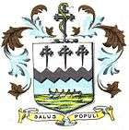
Design a Liverpool/Southport/Lancashire themed plane template
100 years ago the Royal Airforce was formed in
World War One
More than 4,000 people working for the RAF died in that war.
Several of them are buried here in Southport.

We want to honour these people who died to protect our freedoms by putting together a huge display of plane templates and taking some to the cemetery.
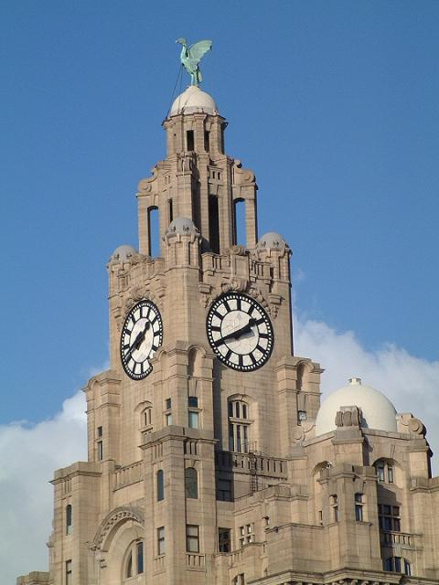
Take a plane template….leave the tail blank to write a local name and on the rest of the plane design RAF images and ones that show this person was from this local area…think of the things that Southport/Liverpool/Lancashire is known for that are easy to draw…images to do with the seaside maybe
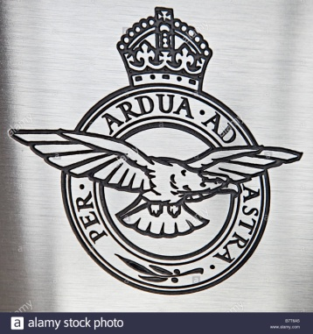
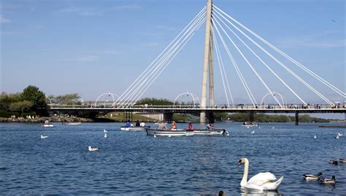
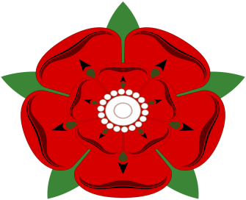
Hand in your planes by Friday June 8th.
Prizes will be given for the best in each class



